Devayn Johnston - CS255

CS 255 System Design Document Template

UML Diagrams

UML Use Case Diagram

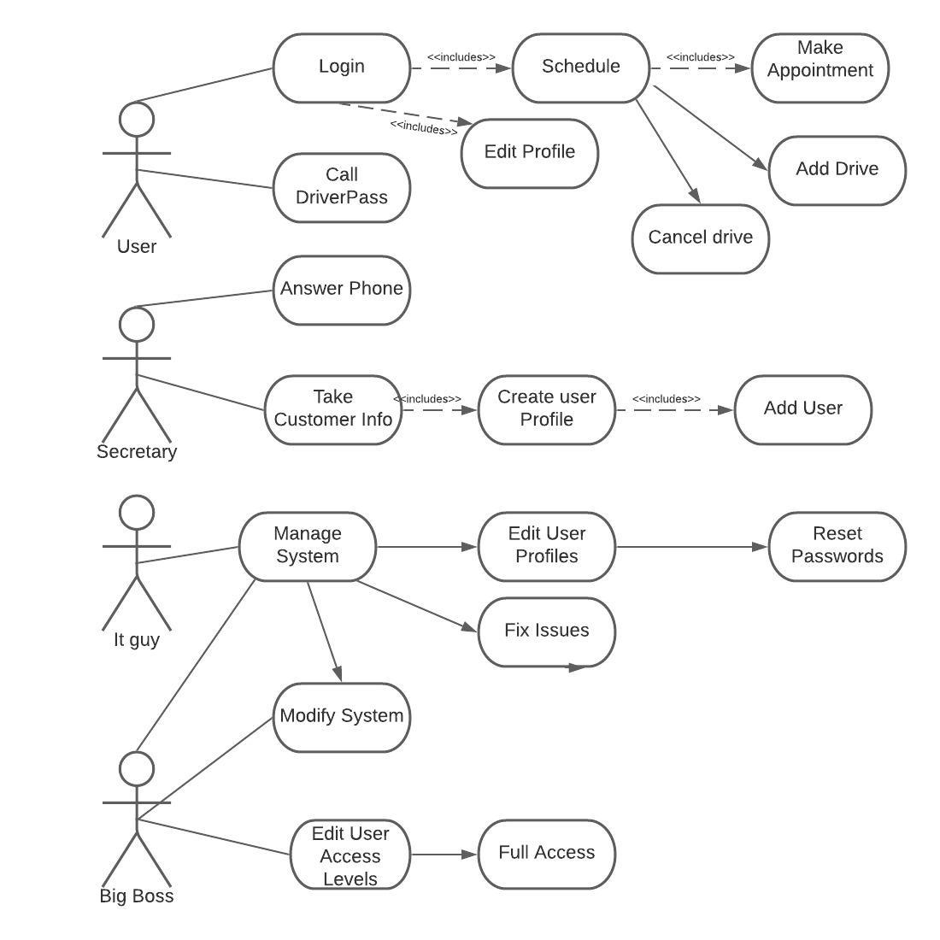

UML Activity Diagrams

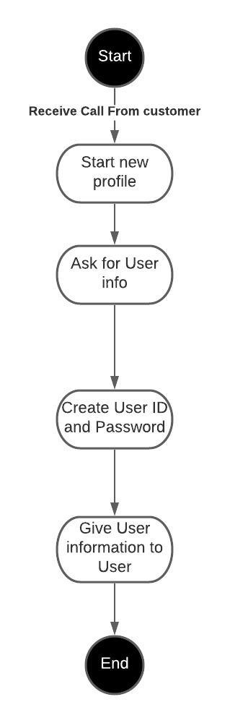

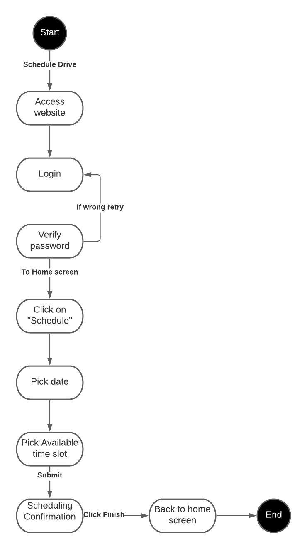

UML Sequence Diagram

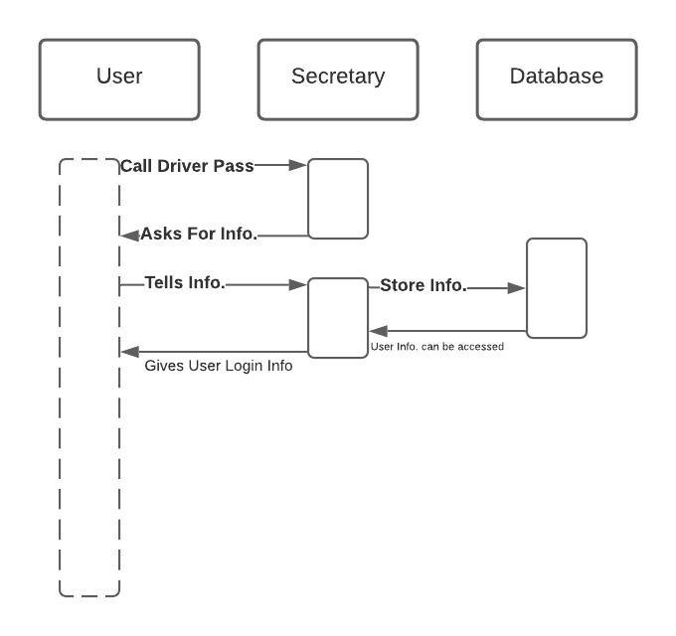

UML Class Diagram

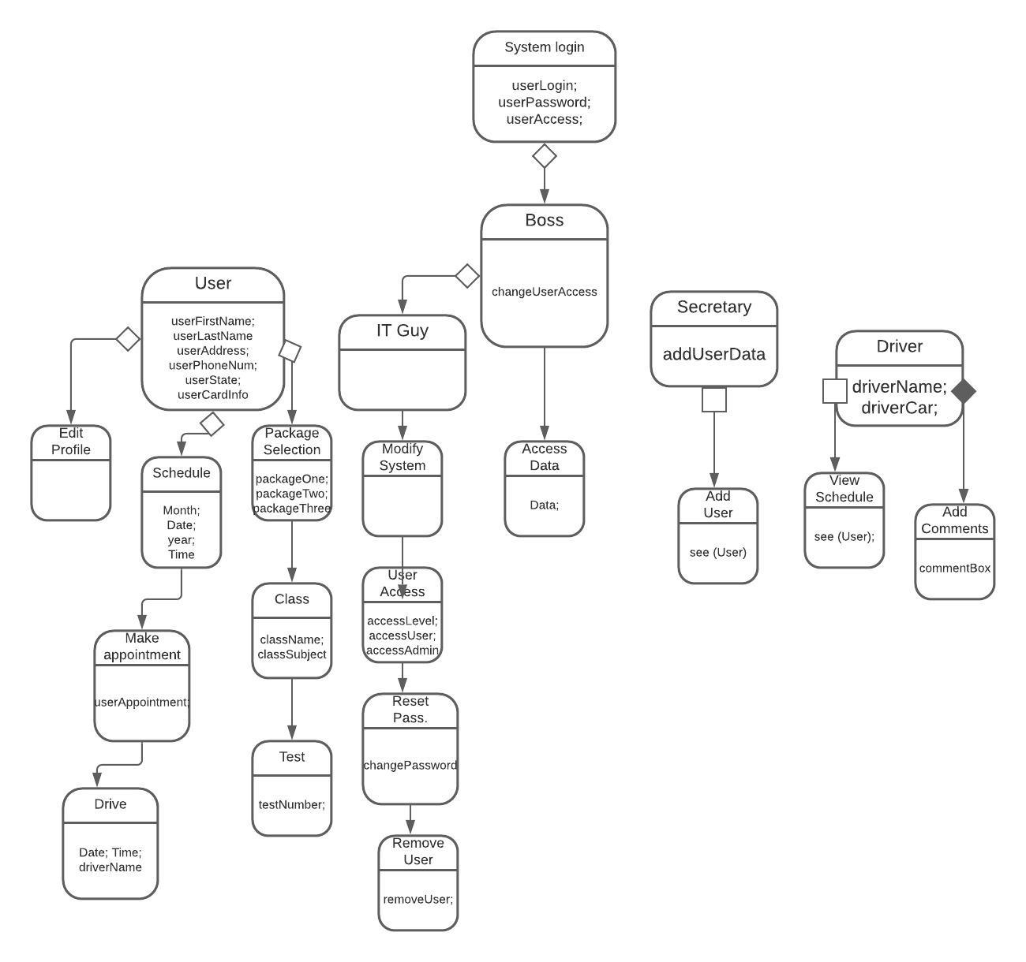

Technical Requirements

Hardware will require a telephone, computer, phone, mouse , keyboard, and monitor. Each will be the required devices to access the system. Next we will have software which can be cross platform from a Mac IOS, windows, linux, or android. Any software is able to access this system. A browser will be needed for any computer while a mobile application will also grant access. Since this is cloud based and ONLINE internet is required. Tools for the system will be a requirement of a car for the drivers.